|  |  |
| --- | --- |
|  | **FPT ACADEMY INTERNATIONAL**  **FPT – APTECH COMPUTER EDUCATION** |

**Centre Name: ACE-HCMC-2-FPT.**

**Address: 590 Cach Mang Thang 8, District 3, Ho Chi Minh City, Viet Nam.**

**INSURANCE**

|  |  |  |
| --- | --- | --- |
| **Supervisor:** | Phạm Thị Lánh | |
| **Term:** | 1 | |
| **Batch No:** | T1.2206.M1 | |
| **Group No:** | 4 | |
| **Order:** | **Full name** | **Roll No.** |
| 1. | Nguyễn Minh Trí | Student1394607 |
| 2. | Lê Thành Lợi | Student1387821 |
| 3. | Nguyễn Võ Minh Quân | Student1394611 |
| 4. | Tạ Công Hải | Student1387807 |

Month 10 Year 2022

This is to certify that

**Mr. NGUYỄN MINH TRÍ**

**Mr. LÊ THÀNH LỢI**

**Ms. NGUYỄN VÕ MINH QUÂN**

**Mr. TẠ CÔNG HẢI**

Have successfully Designed & Developed

**SAFE CAR INSURANCE**

Submitted by: **Ms. PHAM THI LANH**

Date Of Issue: April, 2022

Authorized Signature:

Contents

ACKNOWLEDGE 4

Objectives of the project 5

REVIEW 1 6

1. Problem Definition: 7

2. Customer Requirements Specifications: 8

3. Architecture and Design of the project: 8

4. Site map 10

5. Screenshot 11

5.1 Homepage: 11

5.2 Car categories: 12

5.3 Motorcycle: 13

5.4 Insurance plans: 15

5.5 Login and Account management: 17

5.6 About us: 18

5.7 Feedback: 18

6. Task sheet: 19

REVIEW 2 20

1. Homepage 21

2. Sign in 21

3. Account Management: 22

4. Car: 22

4.1 Under 9 seaters: 22

4.2 Above 9 seaters: 23

4.3 Luxury car: 23

5. Get quote: 24

6. Motorcycle: 24

7. Payment for motorcycle insurance; 25

8. Insurance plans: 26

8.1 Hsbc: 26

8.2 PTI: 27

9. About us: 27

10. Feedback: 28

11. Task Sheet 28

12. Testing document 29

13. Final checklist 29

# ACKNOWLEDGE

eProject is a step-by-step learning environment that closely simulates the classroom and Lab based learning environment into actual implementation. It is a project implementation at your fingertips!! An electronic, live juncture on the machine that allows you to

* Practice step by step i.e. laddered approach.
* Build a larger more robust application.
* Usage of certain utilities in applications designed by user.
* Single program to unified code leading to a complete application.
* Learn implementation of concepts in a phased manner.
* Enhance skills and add value.
* Work on real life projects.
* Give a real-life scenario and help to create applications more complicated and useful.
* Mentoring through email support.

Firstly, our team want to thank our professor for helping us out during the semester. Your help has been invaluable; we don't know how we would have managed without your help and support.

Throughout eProject, we have made a lot of mistakes and learn from them. Thank to APTECH INDIA give us opportunity to practice and challenge ourselves with realistic problem from the project. By that way, we can gain more experience and prepare for future career. Via this project we realize that technology is changing day by day, we have to learn more to improve our skill, knowledge and experience to success in our career.

Best regards,

Team 04.

# Objectives of the project

The Objective of this program is to give a sample project to work on real life projects. These applications help you build a larger more robust application.

The objective is not to teach you JavaScript/Dreamweaver but to provide you with a real-life scenario and help you create basic applications using the tools.

You can revise the chapters before you start with the project.

This project is meant for students who have completed the module of HTML5. These programs should be done in the Lab sessions with assistance of the faculty if required.

It is very essential that a student has a clear understanding of the subject. Students should go through the project and solve the assignments as per requirements given.

# REVIEW 1

## Problem Definition:

Safe Carz Limited is into providing insurance cover for Cars and other vehicles. They provide various insurance policies through different Insurance companies. They now want to provide details of these insurance products on internet. They want to host a website with all the information about their organization and various insurance plans available with them.

The website is to be developed for the Windows Platform using HTML5, JavaScript and Geolocation. The site should work well in all leading browsers including Chrome, IE, Firefox etc.

Requirement Specification:

The Web site is to be created based on the following requirements.

1) Home Page should contain logo of the site with proper sections and details of various Insurance plans available.

2) The site should display a menu which will contain the options for brief introduction about the various categories and plans available, location of the shop and any other information if required.

3) The information should be categorized according to the company names of the Insurance plans like if a User wants to see only “Zurich Insurance” plans or any other company’s insurance plans then he/she can click on a Link/button/menu etc and can see only that Companies plans .

4) Another category option for plans of different type of vehicles, like ‘Four Wheelers’, ‘Two Wheelers’ etc. should be created and accordingly.

5) When a user selects any particular brand, a list of various plans for that brand will be displayed

6) A brief summary about individual plans should be displayed on the Web Page along with the base price.

7) There should be a “Contact Us” page which will have the Address of the Store which is as follows and the mail address which when clicked will invoke the local mail client from where they can send an email. Address of the Company should be displayed using GeoLocation API (eg. GoogleMaps).

## Customer Requirements Specifications:

|  |
| --- |
| USER: |
| Input:   * Customer email, phone number, address, inquiry, brand, insurance plans, type of vehicle * Send request for quotation/get estimate price |
| Process:   * Get the brand, vehicle type, location * Save customer information * Process customer request |
| Output:   * Show estimate fee, detail insurance plan. * Show the store address to consumers |

|  |
| --- |
| WEBMASTER: |
| Input:   * Control website database, input product information… |
| Process:   * Analyse input information and find correct result |
| Output:   * Website interface, images, forms, … * Giving interaction |

|  |
| --- |
| HARDWARE / SOFTWARE REQUIREMENT: |
| Software:   * Notepad/HTML editor * Dreamweaver * IE 5.0/ Netscape 6.0 |
| Hardware:   * A minimum computer system that will help you access all the tools in the courses is a Pentium 166 or better * 64 Megabytes of RAM or better |

## Architecture and Design of the project:

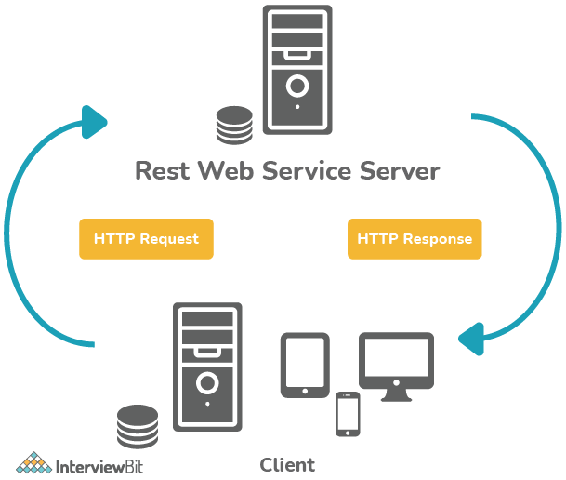

## Site map

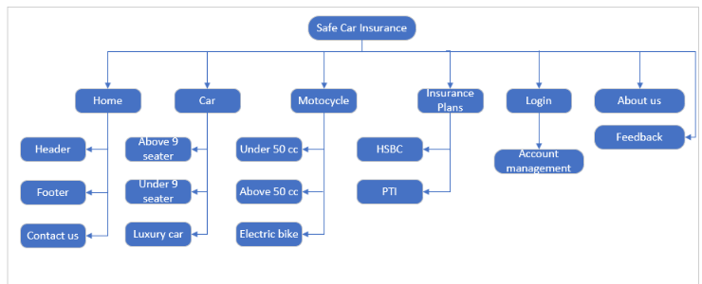

## Screenshot

### Homepage:

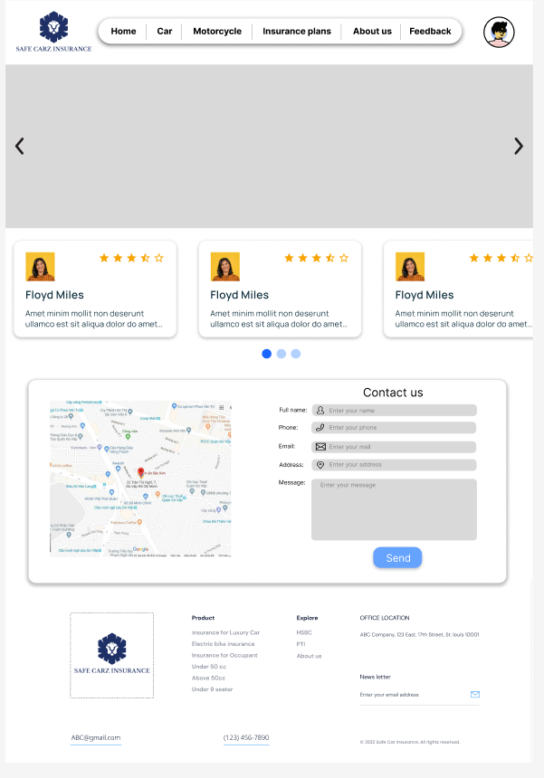

Description: This is a homepage of Safe Carz Limited, the top of this page is a navigation bar, which will have logo and navigator. After that is slideshow for promotion banner. This slideshow will also container link that link to promotion/insurance plans. Then, below the banner is “contact us” section which will have form for customer fill their information and map of company. Finally, footer will be at the end of the page.

### Car categories:

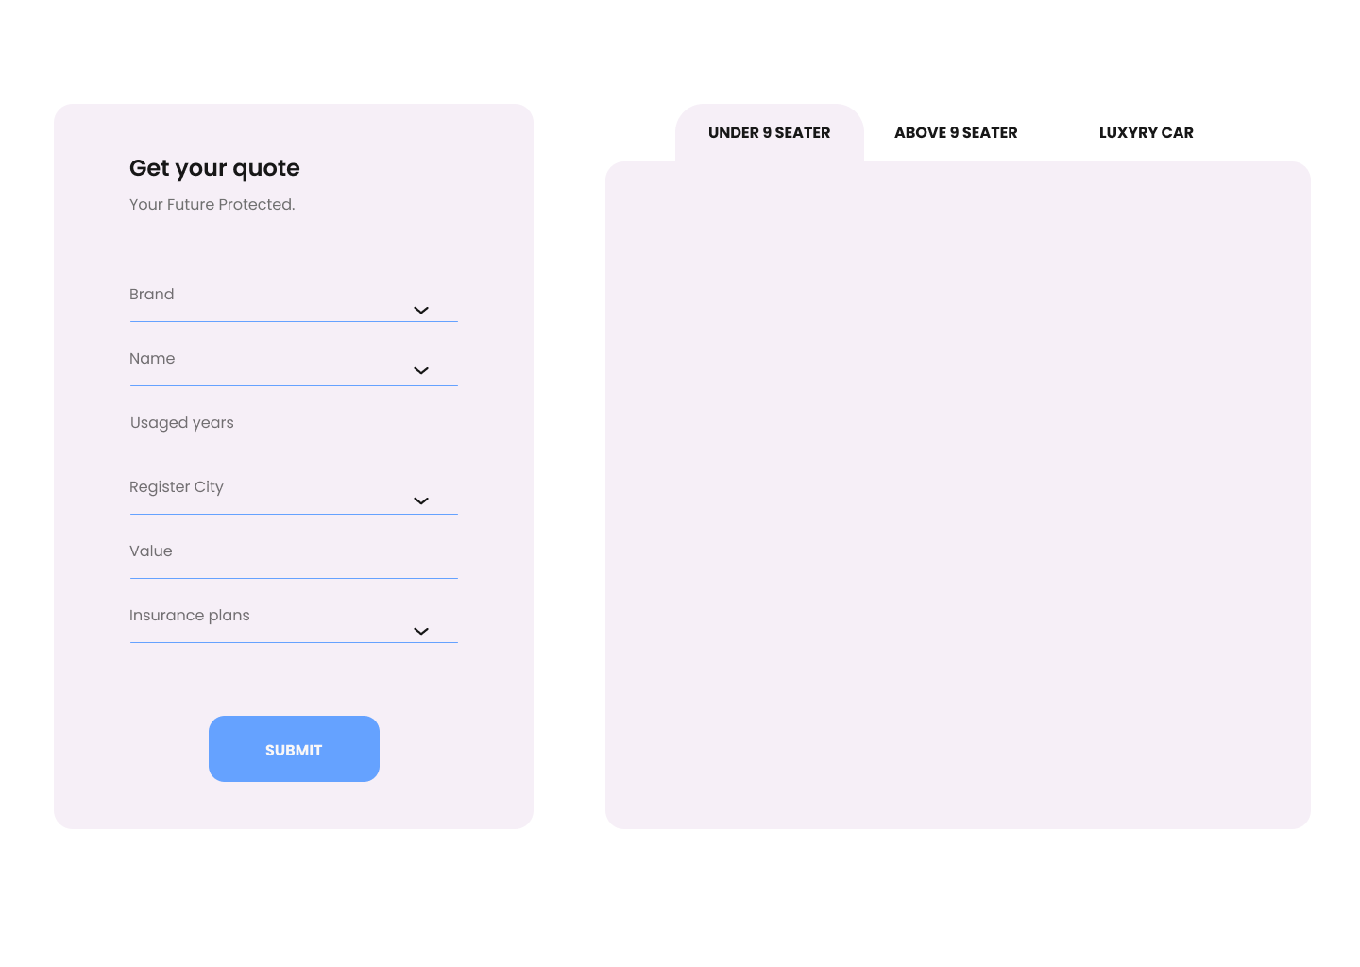

Description: right box is the banner for each type of car, we will have picture and brief of insurance. left box quotation form for client to fill in their information. Whenever, customer click on categories on the left box, form will restrict brand only provide select for which car below 9-seaters.

When they click on “Get Quote” button they will receive the estimate insurance fee as follow picture. The information tab also has contact us button link them to contact page.

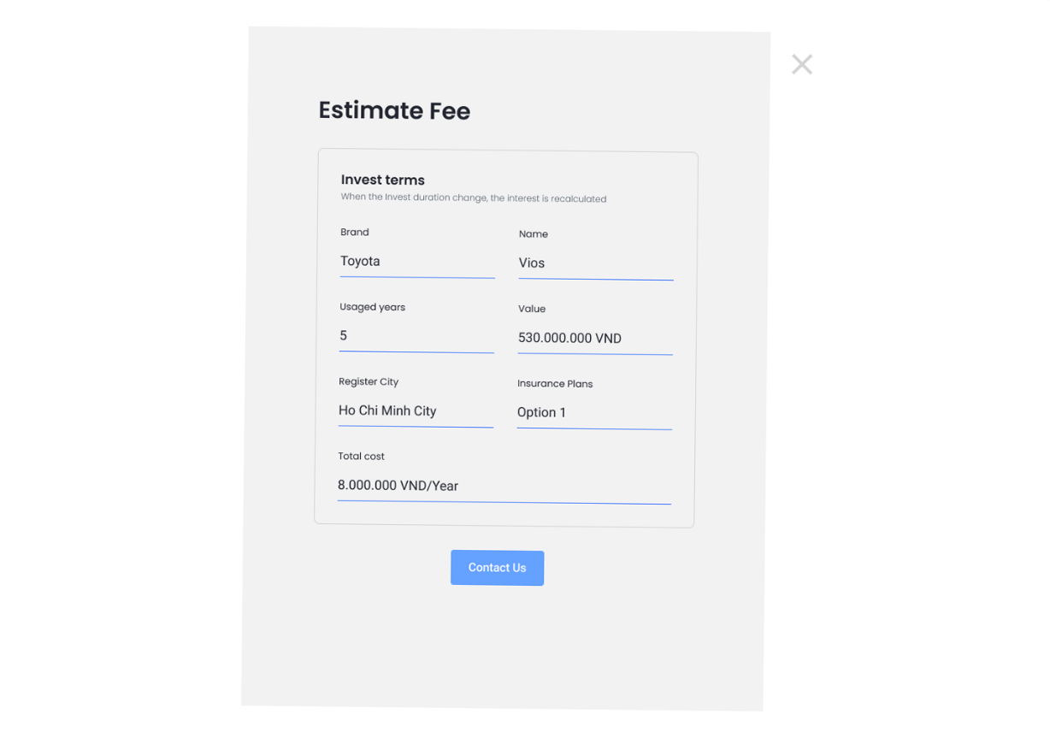

### Motorcycle:

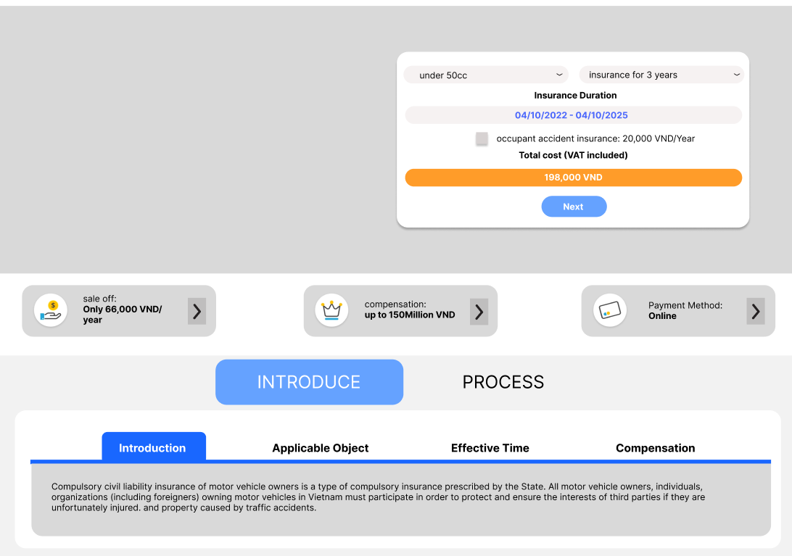

Description: on the top of the page will be banner for promotion. We also have a form on banner for customer to buy the insurance. Customer can choose type of insurance, period, type of motorcycle and check box for occupant insurance. When they click next the form will require them to fill more information as below to process buying insurance:

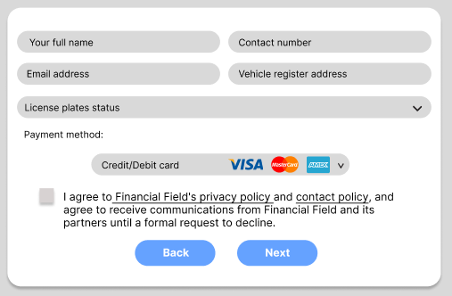

In the form above, client require to fill all require information and select the payment method: credit card or ATM or cash. the form also required them to stick on checkbox to acknowledge the policy. The form have to button. Back previous form and next to process the payment.

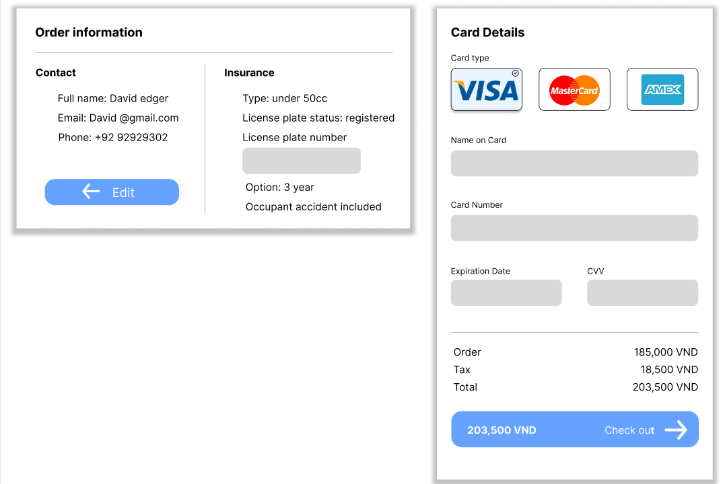

Above is the payment form. To move to this form client is required to login before process payment. They also have to input the license plate number to make insurance contract. There is various card they can use to pay.

Finally, is the introduce of motorcycle insurance and process for received the certificate/contract.

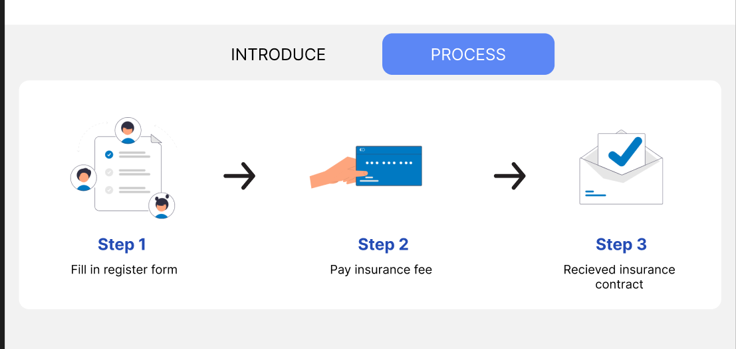

### Insurance plans:

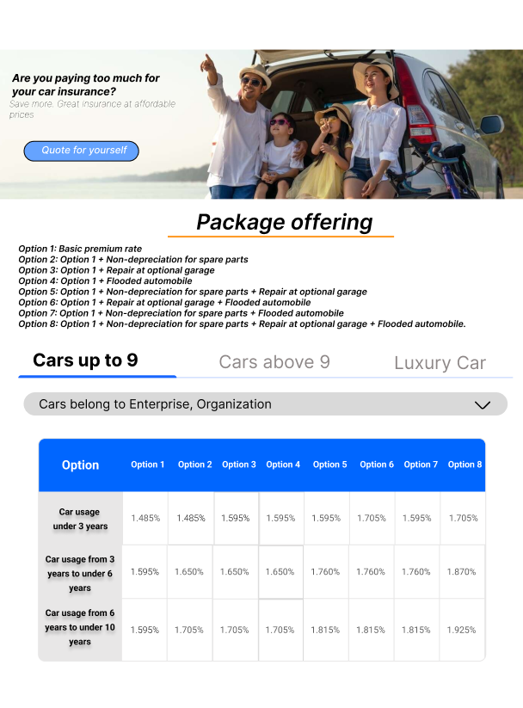

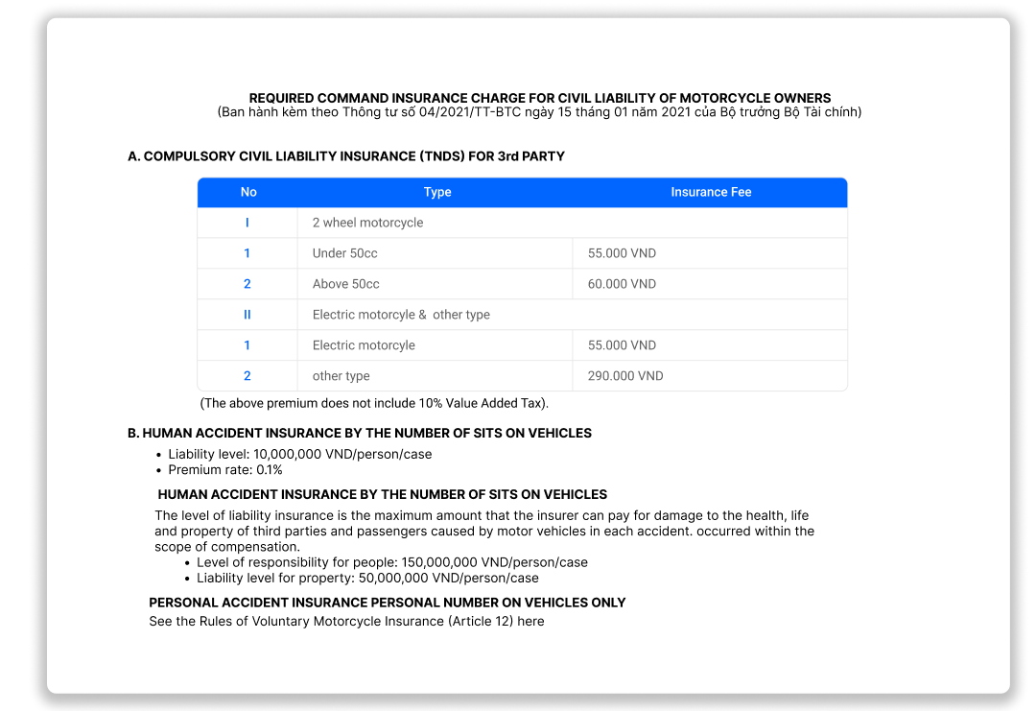Description: This page will show detail insurance plan to customer with various insurance package. The button is a dropdown list for selection package option. The table will change follow each package selected. There also the download link for detail policy. Motor bike will have the same structure.

### Login and Account management:

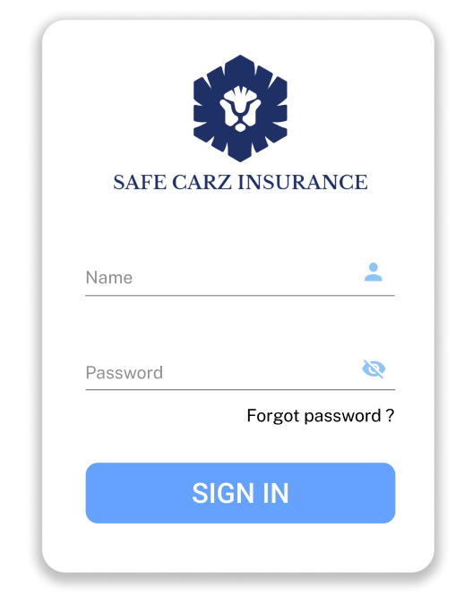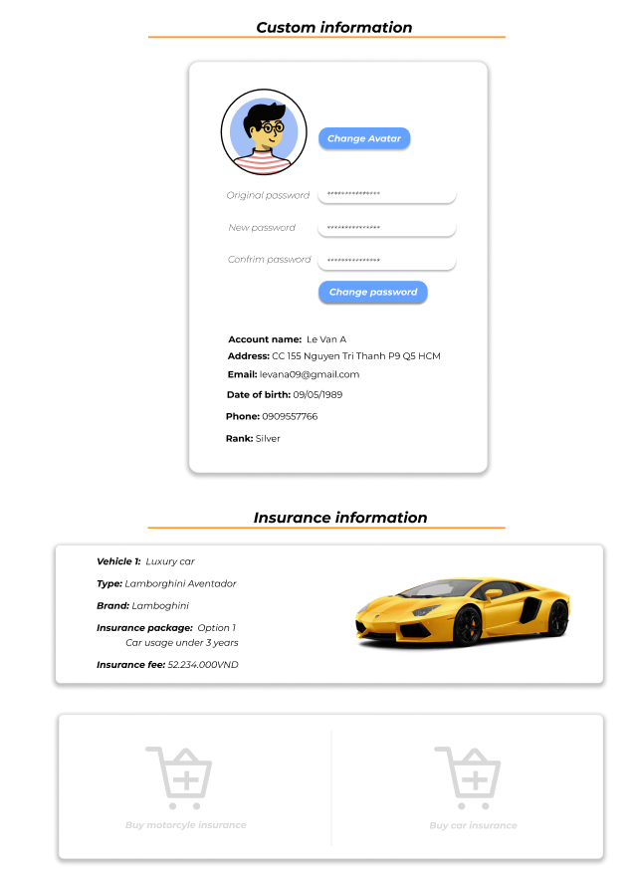

Description: hence, insurance is a unique industry like Bank. Client cannot sign up by themselve they have to provide information to Safe Carz Limited. Service will process the contract then send them username and password. Customer can change their password after they login. They can also add new insuranc contract when they click to cart this will link them to Car or motorcyle page.

### About us:

Description: About us page will show the vision and history of Safe Carz Limited.

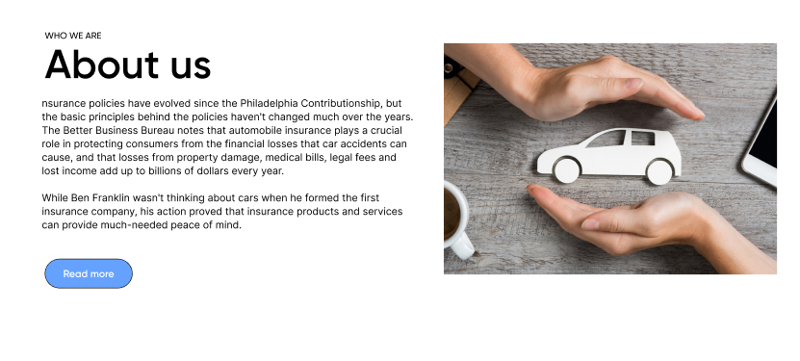

### Feedback:

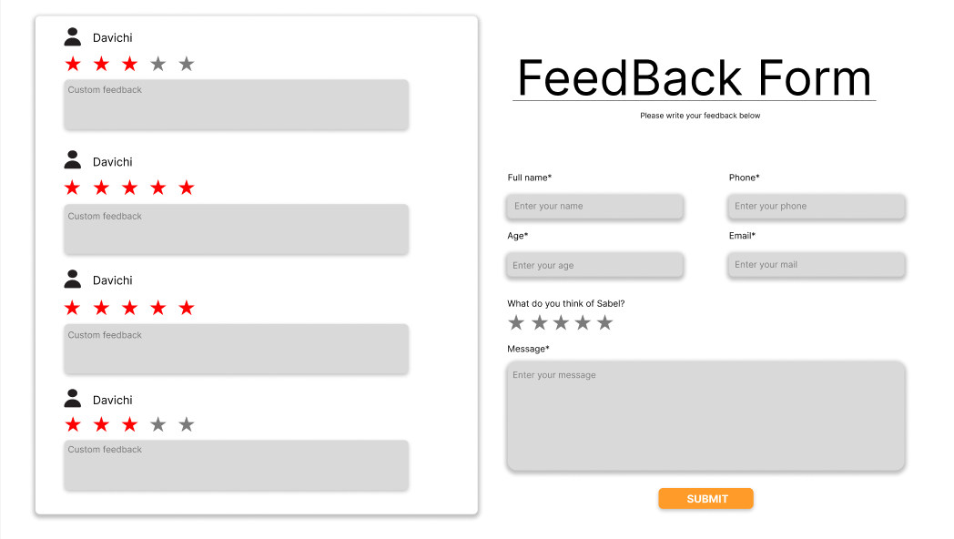

Description: Feedback page will be the place, customer can feedback about the service. Good feedback will also be appear on the homepage to help attractive more customer.

## Task sheet:

|  |  |  |  |  |  |  |
| --- | --- | --- | --- | --- | --- | --- |
| **Project Ref No.** | **Project Title – Ask Me Mobile** | **Activity Plan Prepared by** | **Date of preparation of Activity Plan** | | | |
| **Task** | **Actual Start Date** | **Actual Days** | **Teammate Names** | **Status** |
| Brainstorming ideas for layouts and Project Object | | Tri, Loi, Quan, Hai | 29/09/2022 | 3 days | Tri, Loi, Quan, Hai | Completed |
| Draw site maps and architecture design | | Tri, Loi, Quan, | 8/10/2022 | 4 days | Tri, Loi, Quan, | Completed |
| Wire framing general page layout | | Tri | 06/10/2022 | 1 days | Tri | Completed |
| Collect static assets (pictures, mp4, documentation,) | | Tri, Loi, Quan, Hai | 06/10/2022 | 3 days | Tri, Loi, Quan, Hai | Completed |

# 

# REVIEW 2

## Homepage

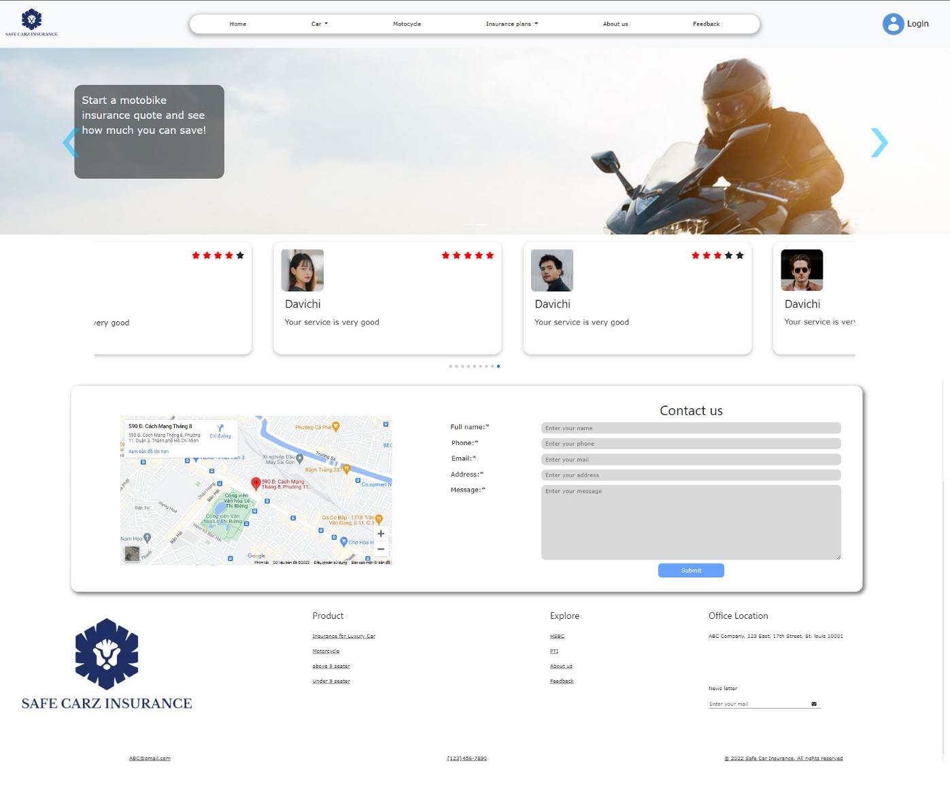

## Sign in

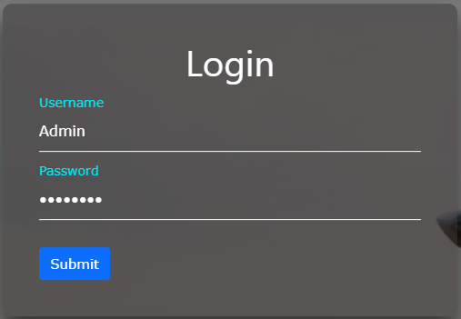

## Account Management:

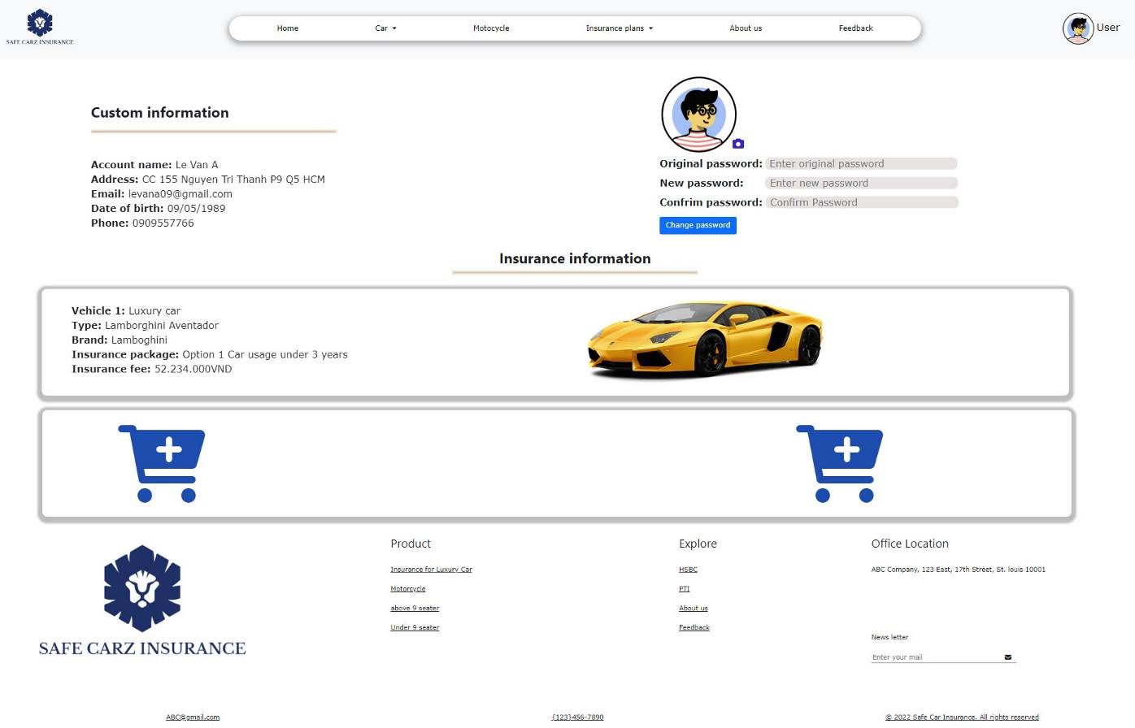

## Car:

### Under 9 seaters:

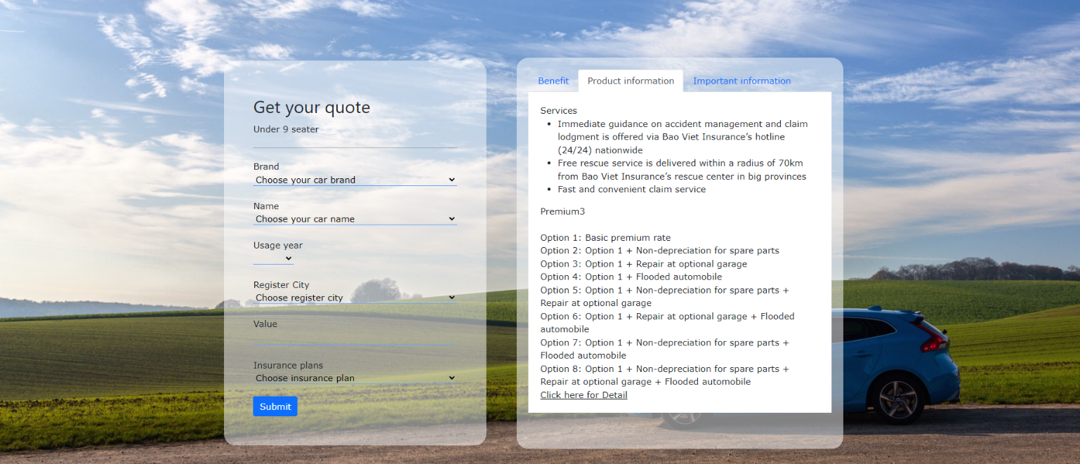

### Above 9 seaters:

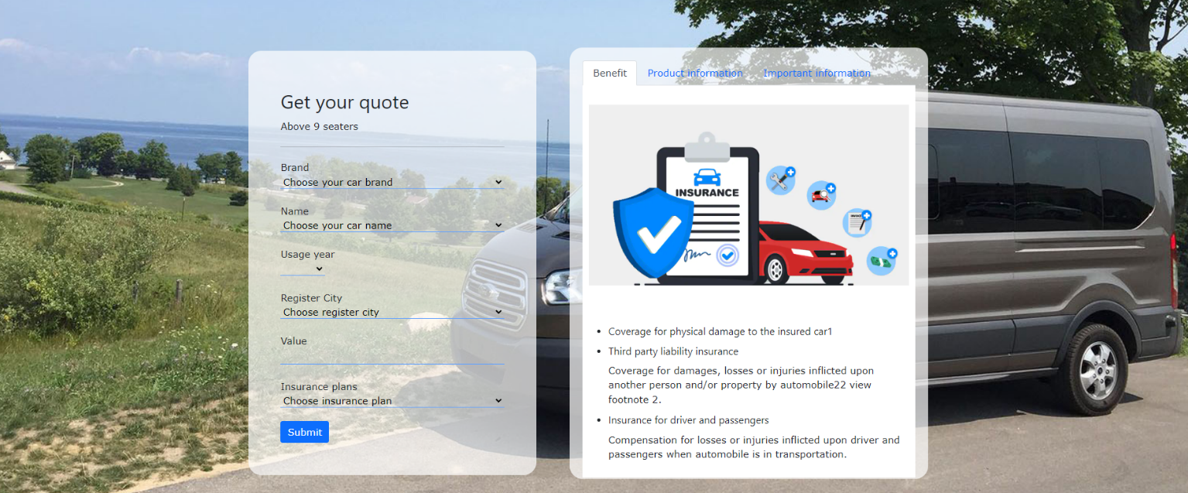

### Luxury car:

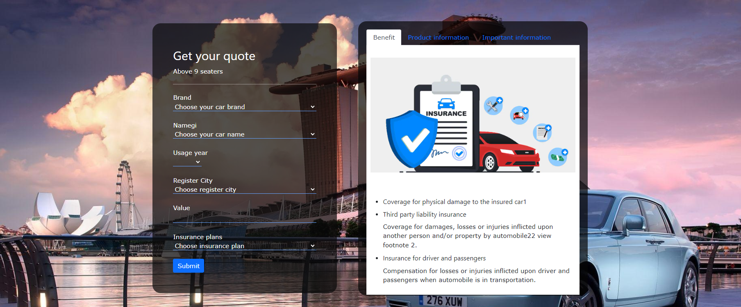

## Get quote:

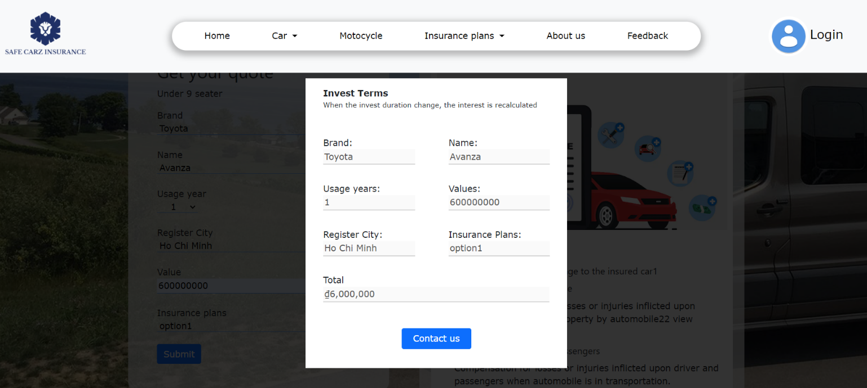

## Motorcycle:

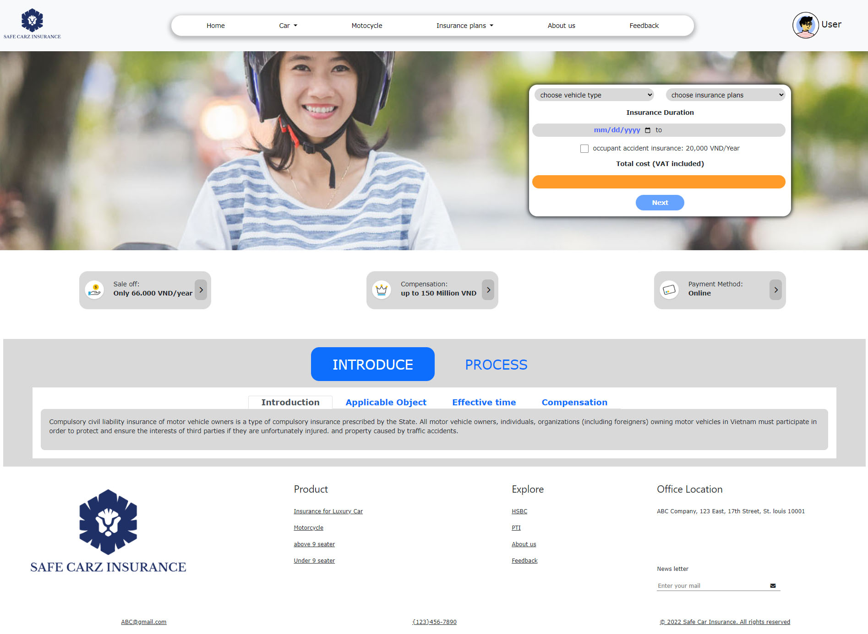

## Payment for motorcycle insurance;

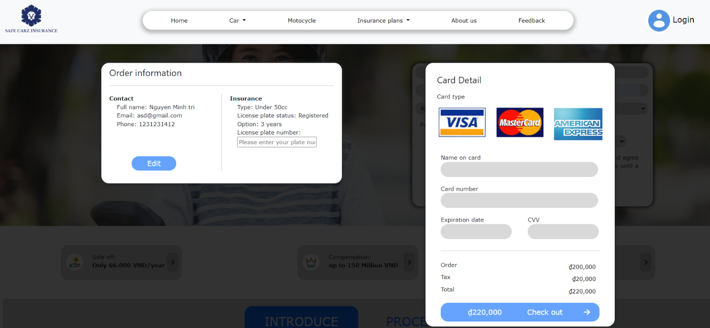

## Insurance plans:

### Hsbc:

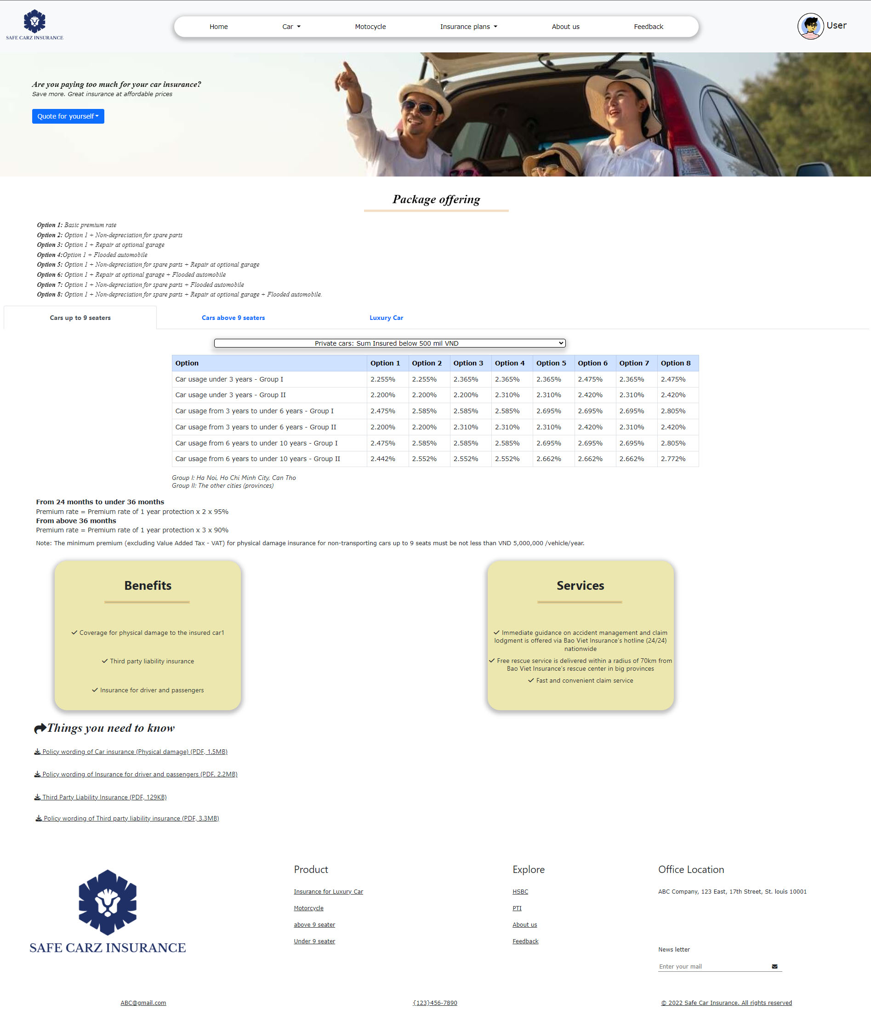

### PTI:

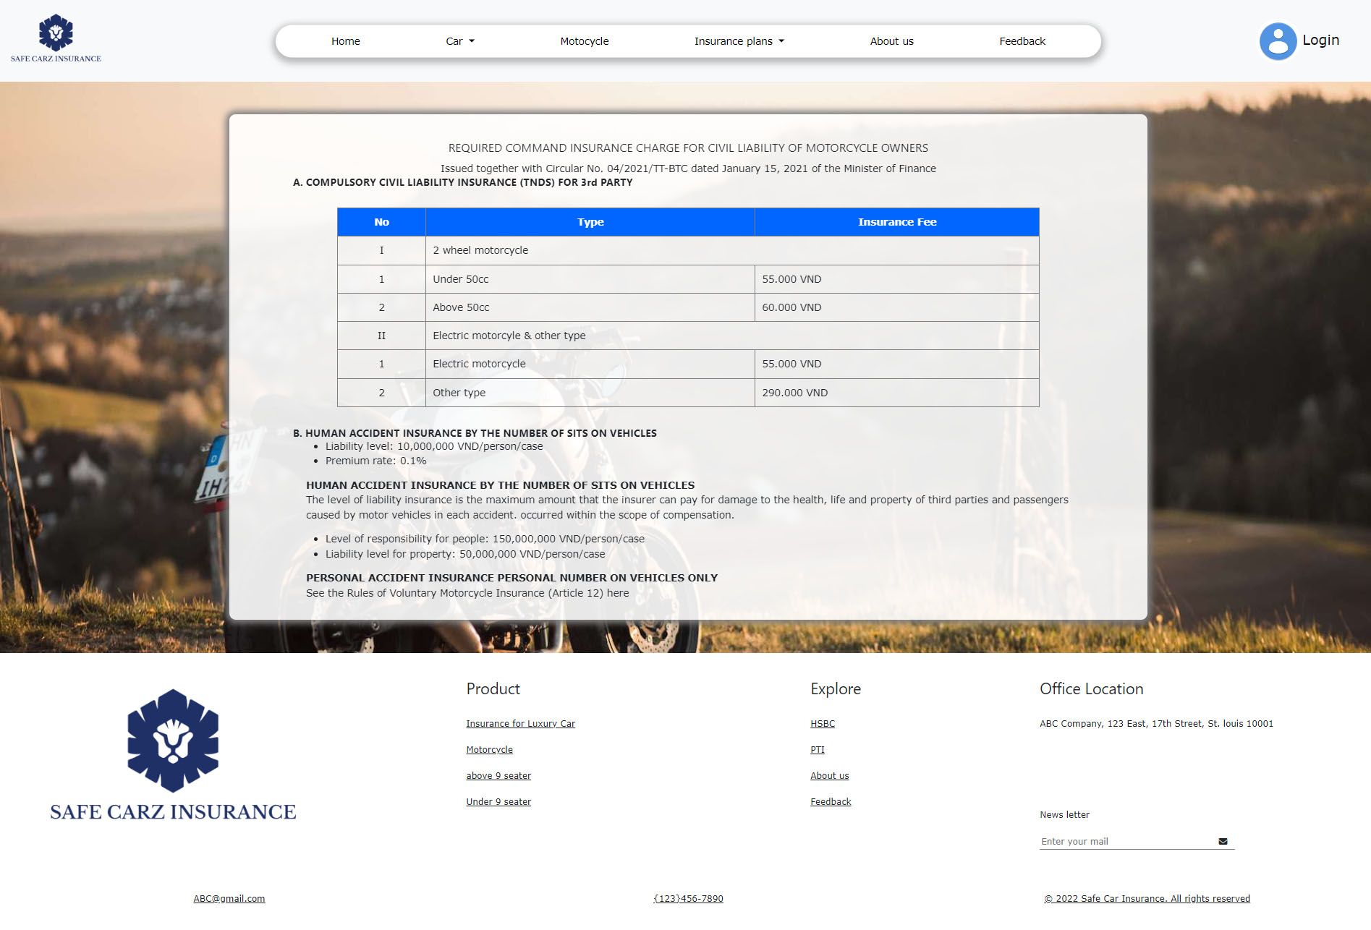

## About us:

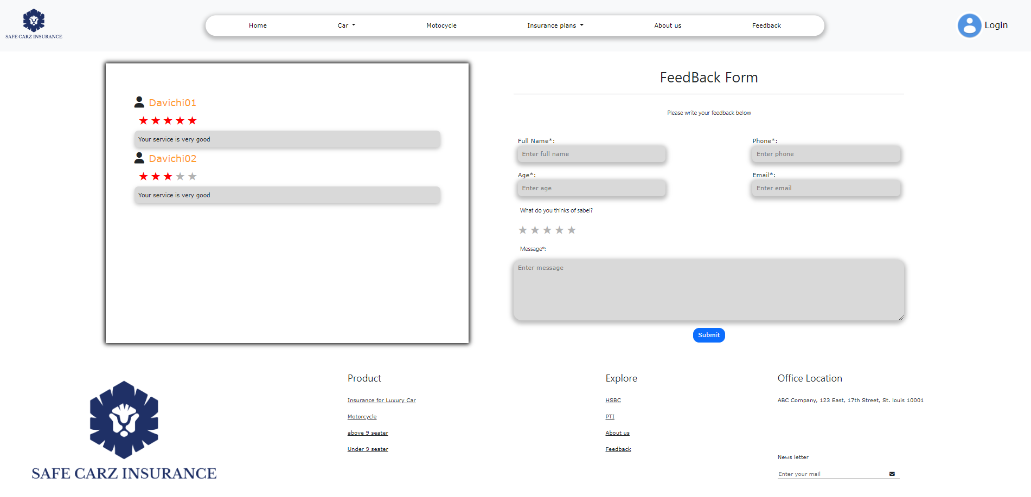

## Feedback:



## Task Sheet

|  |  |  |  |  |  |  |
| --- | --- | --- | --- | --- | --- | --- |
| **Project Ref No.** | **Project Title – Ask Me Mobile** | **Activity Plan Prepared by** | **Date of preparation of Activity Plan** | | | |
| **Task** | **Actual Start Date** | **Actual Days** | **Teammate Names** | **Status** |
| Brainstorming ideas for layouts and Project Object | | Tri, loi Quan, Hai | 1/10/2022 | 1 days | Tri, loi Quan, Hai | Completed |
| Draw site maps and architecture design | | Tri, loi Quan, Hai | 2/10/2022 | 1 days | Tri, loi Quan, Hai | Completed |
| Wire framing general page layout | | Tri | 05/10/2022 | 2 days | Tri | Completed |
| Collect static assets (pictures, mp4, documentation,…) | | Tri, loi Quan, Hai | 08/10/2022 | 5 days | Tri, loi Quan, Hai | Completed |
| Design & Build Homepage | | Quan | 11/10/2022 | 8 days | Quan | Completed |
| Design & Build Sign in | | Loi | 20/10/2022 | 3 days | Loi | Completed |
| Design & Build Account page | | Loi | 20/10/2022 | 5 days | Loi | Completed |
| Design & Build Car page | | Tri | 11/10/2022 | 6 days | Tri | Completed |
| Design & Build Motor page | | Tri | 15/04/2022 | 6 days | Tri | Completed |
| Design & Build Insurance plans | | Tri, Loi | 11/10/2022 | 1 days | Tri, Loi | Completed |
| Design & Build About Us | | Tri | 23/04/2022 | 1 days | Tri | Completed |
| Design & Build Feedback page | | Hai, Quan | 11/10/2022 | 5 days | Hai, Quan | Completed |
| Write Project Report | | Tri | 27/10/2022 | 1 days | Tri | Completed |

## Testing document

|  |  |  |  |  |
| --- | --- | --- | --- | --- |
| **Sr.No** | **Features Tested** | | | **Remarks** |
| 1 | Are all the users able to view the images and links? | | | OK |
| 2 | Have all the views, modules and controllers been | |  | OK |
| properly integrated and is the site function as a single | | |
| page application? | |  |
| 3 | Are the GUI content devoid of spelling mistakes? | | | OK |
| 4 | Is the application user-friendly? | | | OK |
| 5 | Is the Website launching correctly in all popular | |  | OK |
| browsers? |  |  |
| 6 | Are all the forms validated with proper criteria? | | | OK |
| 7 | Do all text links lead to the appropriate website? | | | OK |
| 8 | Do all image links lead to the appropriate website? | | | OK |
| 9 | Are all the images and links clearly visible on the page? | | | OK |
| 10 | Does the Web page work properly in all the tested | |  | OK |
| browsers? |  |  |
| 11 | Does the Web page take too long to be loaded fully? | | | OK |
| 12 | Is the navigation sequences correct through all the Web | | | OK |
| pages on the site? | |  |
| 13 | Is the JavaScript code working as expected in all click | | | OK |

## Final checklist

|  |  |  |  |  |
| --- | --- | --- | --- | --- |
| **Sr.No** | **Features Tested** | | | **Remarks** |
| 1 | Are all the users able to view the images and links? | | | OK |
| 2 | Have all the views, modules and controllers been | |  | OK |
| properly integrated and is the site function as a single | | |
| page application? | |  |
| 3 | Are the GUI content devoid of spelling mistakes? | | | OK |
| 4 | Is the application user-friendly? | | | OK |
| 5 | Is the Website launching correctly in all popular | |  | OK |
| browsers? |  |  |
| 6 | Are all the forms validated with proper criteria? | | | OK |
| 7 | Do all text links lead to the appropriate website? | | | OK |
| 8 | Do all image links lead to the appropriate website? | | | OK |
| 9 | Are all the images and links clearly visible on the page? | | | OK |
| 10 | Does the Web page work properly in all the tested | |  | OK |
| browsers? |  |  |
| 11 | Does the Web page take too long to be loaded fully? | | | OK |
| 12 | Is the navigation sequences correct through all the Web | | | OK |
| pages on the site? | |  |
| 13 | Is the JavaScript code working as expected in all click | | | OK |